

82-2-675-5700 fax 675-0576
mailto:tmc@tmc.co.kr
home-page;http://tmc.co.kr/

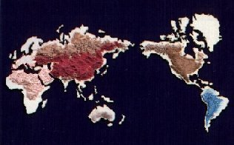

Calcium Iodate Monohydrate

Physical properties

Formula Ca(lO3)2.H2O
Molecular weight 407.90
Bulk density 1.2-1.4 g/cm3
Appearance White granular, free flowing
Screen Size 95% min. thru. 30 mesh

Specification

Iodine(l) 62.0% min
Lead,Pb 20 ppm max
Cadmium,Cd 10 ppm max
Arsenic, As 3 ppm max

Packing

25Kg, Kraft paper bag, Inner Polyethylene film

